

Arizona Department of Education
AIMS Intervention and Dropout Prevention Program
TOOLKIT

Theme – Student-Teacher Relationships
Examples Quoted from Site Staff & Directors
- How would you rate the quality of your relationship with the students? Please explain your rating of your relationships with students.
- What special skills or techniques do you use in working with the AIMS IDP students that produce positive outcomes for them?
- Overall, what components of your program would you say contribute most to student success?
When asked, “How would you rate the quality of your relationship with the students?”
Staff responded:
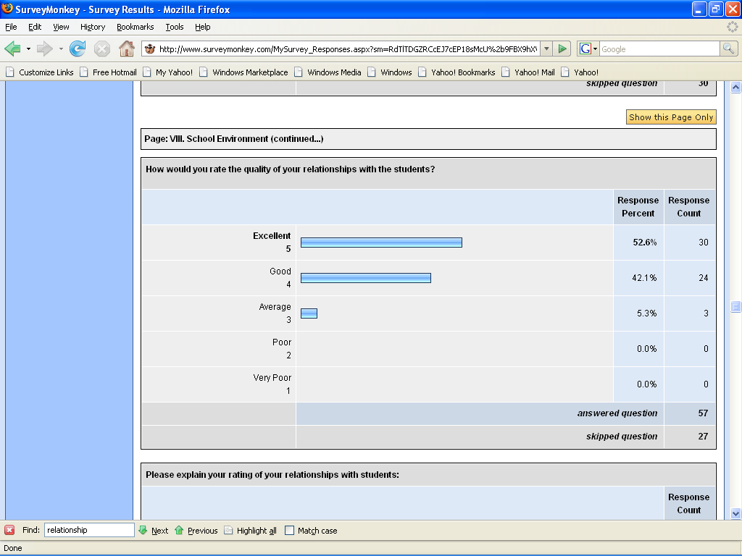
When asked to “Please explain your rating of your relationships with students.”
Staff Quotes:
- “I believe I have an excellent relationship with my students, mainly because I am non-confrontational with them. I enforce rules fairly and consistently, and everyday I wipe the slate clean. I take a sincere interest in my students' activities outside of school and try to support them by coming to events or learning more about their hobbies. In my class we do lots of different activities which prevents frustration from boredom (and the inevitable misbehavior that can cause). And I am happy to see my students everyday-- and they know it!” (Project CORE, Scottsdale Unified School District)
- “I have empathy for the tough issues many of our students are dealing with. The students who know me, know that I am an advocate for them. I prove this to them by making things happen for them in order for them to get second (and third chances), flexible schedules, make-up opportunities, advocating to teachers and administrators and listening to their suggestions.” (Page High School)
- “According to student and parent surveys, the majority of those responding agreed that the staff and administration treat students with respect and are fair and consistent with the rules.” (Buckeye Academy)
- “Students know I have high learning expectations but also care about their lives.” (Project CORE, Scottsdale Unified School District)
- “I am the teacher here at the Career Center's Independent Learning Center. I work with almost all students on a daily basis, whether it is helping them with coursework or helping them to set short term goals for finishing their work. I never have more than 10 students at a time to work with, so I am able to work one-on-one with most students when they need assistance. The students are very independent, but they know that I am there to support them if they should need it.” (Coconino Career Center Independent Learning Center)
- “I believe students recognize that I am diligent, caring, and rigorous. They know that I believe that they will learn best and "most" through a program that stresses hard work. I try to lead by example. No putdowns, no criticizing in public, no excuses.” (Project CORE, Scottsdale Unified School District)
- “My students are told and see that the reason for my job is to help them. They feel valued because they are part of GEAR UP. Every statement I make to them is encouraging or supportive. My role is to build them up so they can accomplish their goals.” (Arizona GEAR UP)
- “The highest compliment I've ever received is that I am "real". I am irreverent, use much humor, and will thoughtfully and honestly respond to questions. Kids know they can ask me - and if I don't know the answer, I'll help them figure it out. The biggest thing? I like kids. I have an extraordinary respect for those that are trudging along in bad experiences, and yet, they come to school. That's a celebration in and of itself.” (Ponderosa High School)
- “Students feel free to joke with us, speak seriously with us, and take necessary correction from us. This important relationship is the basis for the students' growth and success in school.” (Youth Excel Program – YEP)
- “I feel that when working with this population, it is a challenge to have an excellent relationship with each and every student. Staff members can give it our all, but the truth is that the students need to reciprocate, as well. Sometimes it is a struggle to get that buy-in. However, through persistence and perseverance some of these barriers can be broken and an effective relationship can be built.” (Marcos de Niza High School)
- “The relationship I create with the students I work with is supportive and understanding. I try to get to know the students’ situations so I can identify any needs and/or support outside of school they may need. I have helped families get into homeless shelters, drug counseling, parent support groups, counseling programs for teen parents, grief counseling, etc. Many parents have called me and thanked me for the extra mile our guidance department tries to go for each family we work with.” (Primavera Work Force Connection Program)
- “We sincerely care about the students. Even during special events when there is no tutoring after school, students will just appear (and object if we say the session is cancelled). This is due to our great relationship with them. They always want the tutoring. They never want the administration to cancel it for a special staff meeting, which happens sometimes.” (Baboquivari Middle School)
- “I understand where these students come from and deal with since I grew up in their communities.” (Youth Empowerment Project, Center of Excellence)
- “The school that we serve is a small closely knitted community. We emphasize interaction with the students and parents.” (Baboquivari High School)
- “I have met and counseled every student in the YEP program. I understand the problems that they face and try to offer constructive ways for them to deal with their problems. I have worked with at risk students for the last 25 years.” (Youth Empowerment Project, Center of Excellence)
- “Overwhelm them with courtesy and respect. Being overly courteous puts them off a bit, and usually they respond to it. Talking to them individually and learning little things about them, helps to get them to participate and try harder to complete the Plato lessons.” (Villa Oasis Interscholastic Center for Education)
- “Students let me know they are comfortable talking to me, evidenced by sharing personal information and by requesting help on how to deal with specific issues within and outside of the JAG Program.” (Sunnyside High School Multi-year Program)
- “Overall, our relationship with students is good. We keep in close contact with them. There are a few that aren't very good about calling back when messages are left with them, but for the most part, we are open with one another. Our support of the mentors, tutors, and students helps keep the lines of communication open.” (Big Brothers Big Sisters of Flagstaff AIM HIGH Program)
- “I am always there for them. I find out who they are and what they need and do the best to provide them with it. I expect the best and in the long run they see I care even when I call them to task. I have a 2-3 year relationship with them. I am caring, and loving, and smile a lot.” (JAG, Coronado High School)
- “The post-program essays completed by the students overwhelmingly indicated that they developed strong relationships with the program staff. Comments by the students highlighted how much the program impacted their attitudes and behavior toward the adults in their lives.” (MPS AIMS I.D.P. PAY Program)
- “The role of a JAG Coordinator is above the role of a traditional high school teacher. This role includes: after-hour time, individual tracking/support for the student, one-on-one communication daily.” (JAG, La Joya Community High School)
- “We complete many projects together and the students know that I genuinely care for their success.” (Jobs for Arizona's Graduates)
- “The relationship I have with the students is key to the success of the program while I have them in school and during follow up. The one-on-one opportunities and individual graduation plans helps create the open communication I have with each student. They know that I believe in them as they should believe in themselves.” (Jobs for Arizona's Graduates)
- “Sometimes it’s not in what you say, but it is how the students SEE you live and get to know who you are genuinely, without asking anything.” (I-Learn Program)
- “I have a great rapport with students, and they freely come to me when walking across campus or when visiting a classroom. They see me supporting their efforts and activities. I give them respect and they recognize it.” (Millennium)
- “The ability to interact with students in after school sports is critical in gaining their trust and respect. Plus we create plans to maintain our students athletes are on track to graduate.” (Desert Edge High School)
- “Students open up to staff and trust to help them get through school. Students are very cooperative with staff even when they have broken a school rule and are being disciplined.” (Compadre Satellite Alternative School)
- “We take the time to know our students. With 130 students, each teacher has a large proportion of the student body in their classes. We also use a modified 4x4 block schedule that gives us 80 minutes daily with the students. This extended time gives us extra time to spend with students individually.” (AIMS Supplementary Program, RCB Medical Arts HS)
Director Quotes:
- “We have spent an exceptional amount of time working individually with students. Conferences, grade check, revising individual papers, assemblies and guest speakers about school attitudes and long life needs.” (Project C.O.R.E.)
- “The students know that they can come to the staff at anytime to ask questions and voice concerns. There is a level of respect between the students and the staff that allows friendly, yet professional, relationships between both parties.” (Coconino Career Center Independent Learning Center)
- “Students contact the teachers and staff frequently either via email or phone. They willingly and voluntarily share their problems and goals. Primavera staff prides in having excellent rapport with parents and students.” (Primavera Workforce Connections Program)
- “The students who needs extra help are not always willing to attend the tutoring sessions daily, therefore; they tend to be slower in developing excellent work relationships---with faculty members and among themselves.” (Pinon High School AIMS IDP Program)
- “Mutual respect is earned with some effort, but it is invaluable in facilitating a student's academic success. YEP Specialists are always honest with the youth and respect the intelligence and experience the student brings to the relationship.” (Youth Excel Project-YEP)
- “As a result of the mentoring program, staff and students have built positive relationships and staff member knows each student by name and knows their goals.” (School to Career Transition Program)
- “Since this program is voluntary and requires (due to transportation issues) students to stay on campus until 6:00 p.m. (and they may not get home until after 8:00 p.m.). We literally must have good relationships if we want the program to succeed at all. We try to stress how important our students are and how important their educational goals are to themselves and to us.” (Indian Oasis Baboquivari Unified)
- “Students are coordinated into smaller learning communities to enhance the quality of the relationship between students and staff. This has proven to be an effective implementation strategy.” (Mesa Public Schools PAY Program)
- “Ask the students - 90% of JAG students will tell you that the JAG Program Coordinator knows them and cares more about them than anyone else on campus and many times more than any adult in their life.” (Jobs for Arizona’s Graduates)
- “Students respond to individual attention. The peer culture tends to be negative, so classroom instruction is often disrupted by negative attention seeking behavior. Overall, the students understand the staff want them to succeed.” (YCFA Achieve Academy)
- “Students know that OnTrack is there to help them. Counselors inform the students of the requirements of OnTrack and then the OnTrack coordinator follows through to make sure the students are fulfilling these requirements. The students, in most cases, seems to know that when they need help outside the school's responsibility, that OnTrack is there to assist and help them obtain extra credits through any academic avenue available. OnTrack is a relationship between staff and student of support for their success.” (OnTrack)
When asked, “What special skills or techniques do you use in working with the AIMS IDP students that produce positive outcomes for them?”

Staff Quotes:

- “I fundamentally believe that many at-risk students have been let down by adults in their lives. They are wary and tend to take a while to trust you. We must work to earn their trust and this must be tangible. It must be actions that prove we will go the extra mile for them, not just lip service, not just encouragement and happy thoughts. Many of these students will not respond immediately. I believe on some level, they think, "and this too shall pass". We must stay determined to be in support of them as deserving young adults; we must continue to care when they try to discourage us. Many, many times, I have had a student come back a year or longer and suddenly "get it". Keep pouring in the support, don't give up on them - that's what many have already experienced over and over. Get them to realize that this time will be different and you will stay on their side. Tenacity is one of the work-horse tools that must be in the tool box along with a thick skin and the attitude of giving without always seeing immediate results.” (Page High School Dropout Prevention)
- “I try to be fair, consistent, and empathetic to the needs of our students.” (Buckeye Academy)
- “Independent studies in English help some students make up credits. I am a certified English teacher and so can set up the independent study and work with the student to successfully complete it. Always being accessible is a technique that supports the students emotionally and educationally which paves the way for success. Also, being relaxed and respectful of the students goes a long way in helping them toward success.” (Youth Excel Program - YEP)
- “1. Praise and encouragement 2. Helping them problem-solve and not handing them the answer. 3. Letting the students "own the problem" and have them figure out their goals in relationship to it. 4. Reward them through incentives in front of their peers. 5. Humor-the ability to laugh at a circumstance and then create a strategy to conquer it. 6. Letting their parents know of their successes and achievements.” (Marcos de Niza High School)
- “Listening skills, time management and study skills, building rapport with student to create a trusting working relationship.” (Primavera Work Force Connections Program)
- “Mutual understanding and being a positive role model.” (Choice Program, Shonto Prep High School)
- “In most cases, in my mentoring and tutoring groups, just showing that you care and being "real" with the students leads to positive outcomes...unfortunately, most parents are not that involved in their lives, so any positive adult attention is in most cases openly welcomed and therefore leads to success.” (School to Career Transition Program, Superior School)
- “The staff are very involved in each student's education and mentoring groups help them create additional bonds with other adults. Caring staff has always helped us with positive outcomes for our program.” (Arizona Charter Academy)
Director Quotes:
- “The staff that works directly with the ILC program is in constant contact with the students. The Career Coach is required to meet with each individual student at least once a month, but it oftentimes ends up being much more frequently than that. The ILC Teacher sees the students on a daily basis when the students come in to work in the lab. Student questions can be answered and progress can be monitored as much as possible. Both the Career Coach and the Teacher have an open-door policy with the students and treat the student's concerns as their utmost priority.” (Coconino Career Center Independent Learning Center)
- “I don’t know if you would call this a special skill or technique, but they listen to their students. In advisory, the teacher is one member of that student's support group. We have found when a student can make that connection, it helps produce successful outcomes.” (Agua Fria Union High School District #216)
- “YEP Specialists are available to a student at any time during the day for counsel, a word of encouragement, or advocacy when the student is in trouble. Being the constant caring adult can be a powerful way to help students to success. The project-based learning model is also a technique that allows students to grow and shine regardless of academic achievement.” (Youth Excel Project-YEP)
- “The personal relationship is the key to successful outcomes. Some of the teachers and staff have extraordinary caring relationships with at-risk students. There are students who literally would not be in school were it not for these teachers and staff. Again, home visits are important, as well as individualized sessions that often really are more mentoring as well as instructional time.” (Indian Oasis Baboquivari Unified)

When asked, "Overall, what components of your program would you say contribute most to student success?"
Staff Quotes:
- "A strong relationship with a caring adult who is safe and familiar. I will be with my students until they graduate from high school. The relationship I build with them and their family is the single most effective strategy of my program." (Arizona GEAR UP)
- "Constant positive communication with students, parents, and teachers. Helping student work on daily schedules, working with them to develop good study skills and healthy habits" (Primavera Work Force Connection Program)
Director Quotes:
- "Building relationships with students and raising their expectations of themselves and encouraging them to do better. Again, it's relationships, not programs, that change children. If you see our budget, the AIMS IDP director and staff are the largest encumbrance of the budget. We should be the biggest factor in the success of this program and without forming healthy relationships with students-we won’t go anywhere." (Kingman Unified AIMS IDP Program)
- “I believe that the individual attention and the number of resources that YEP Specialists can muster for a student are primary components of the program. This relationship allows the youth to learn and succeed in school which is the purpose of YEP.” (Youth Excel Project (YEP))
- “Individualized/small group tutoring; Home visits by teachers and O'odham staff; Involvement of students in their own learning (i.e., the Comic Book project) Supportive, caring environment created by the teachers; and staff Educational Field trips (they are great motivators out here)” (AIMS Intervention/Dropout Prevention After School Program)
- "The single activity having the most impact, by far, has been the one-on-one meetings held between GEAR UP site coordinators and students at all of the GEAR UP schools. Termed Postsecondary Education Planning Sessions (PEPS), these interactions are a core strategy of our six-year project, intentionally designed to cultivate the long-term relationships that were proven effective in helping cohorts of students succeed under the first Arizona GEAR UP project. Under standards promulgated by the State Office and adhered to by Site Coordinators, the relationship-building PEPS sessions in the first year, begin with: Helping each student understand the value and benefits of GEAR UP over the next six years; Exploring each student’s interests, hobbies, hopes, dreams, talents, and strengths, including career interest areas and postsecondary aspirations; and, Reviewing student’s academic status and discussing need for summer school / credit recovery, if applicable. In essence, Year-One PEPS are the “launching” of GEAR UP -- not at a project level, but at the people, student level." (Arizona GEAR UP)
Return to Key Themes Page

