Q: What is a DUNS number? How are they assigned? Is there a charge for U.S. Government contractors? (https://www.bpn.gov/ccr/FAQ.aspx#duns)

A: A DUNS number is a unique, non-indicative 9-digit identifier issued and maintained by D&B that verifies the existence of a business entity globally. D&B assigns DUNS numbers for each physical location of a business. All U.S. Government contractors globally can receive a DUNS number at no charge and, under normal circumstances, within 1-2 business days when using the D&B web form process. If requested by phone, a DUNS can usually be provided immediately.

- D-U-N-S Request by Phone

For U.S., Puerto Rico, and US Virgin Islands Requests only
Contact the D&B Government Customer Response Center
U.S. and U.S Virgin Islands: 1-866-705-5711
Alaska and Puerto Rico: 1-800-234-3867 (Select Option 2, then Option 1)
Monday - Friday 7 AM to 8 PM C.S.T.
The process to request a D-U-N-S® Number by telephone takes between 5 and 10 minutes.
You will need to provide the following information:
- Legal Name
- Tradestyle, Doing Business As (DBA), or other name by which your organization is commonly recognized
- Physical Address, City, State and Zip Code
- Mailing Address (if separate)
- Telephone Number
- Contact Name
- SIC Code (Line of Business)
- Number of Employees at your location
- Headquarters name and address (if there is a reporting relationship to a parent corporate entity)
- Is this a home-based business?

- D-U-N-S Request by Web

How to search the existing DUNS number or request new DUNS number via Web
- Go to http://fedgov.dnb.com/webform/CCRSearch.do

- Select a county : United States of America
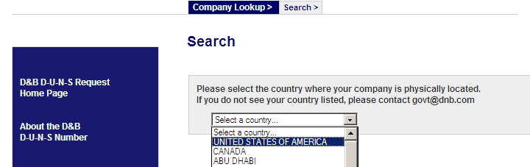
- Enter Business Name, State, the verification code shown. Click Submit
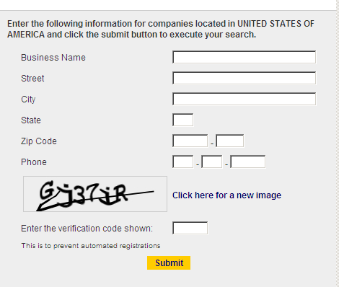

- Search Results Screen
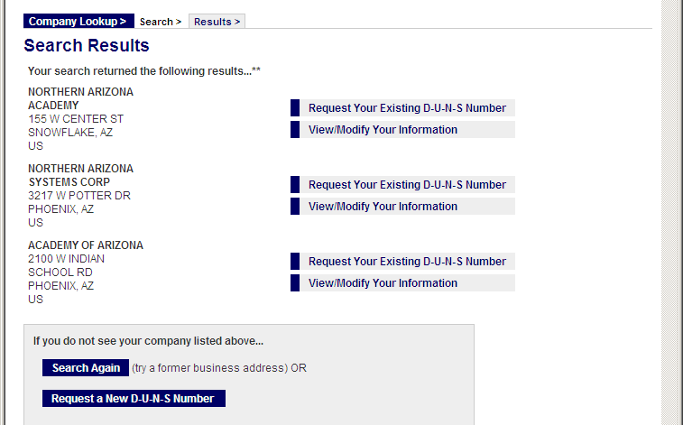

- If you do not find your LEA in this search Results from #4, simply click on Request a New DUNS number and complete the form.

[LEA requesting Existing DUNS number]
- If you see Search Results with your LEA name (see screen above # 4), you can click on Request your Existing DUNS number – complete Contact Information.
Complete contact information as below and submit
- You will receive an email with DUNS number.
